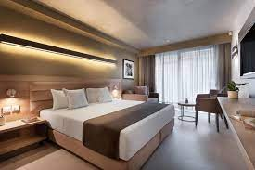

**Hotel**

**Booking**

**System**

Specification

Hatfield Hotel is a multi-room hotel for which rooms can be booked through an on-line system. Each room is of a specific type:

* Single : contains a single bed, sleeps 1
* Double : contains a double bed, sleeps 2
* Twin : contains two single beds, sleeps 2
* Family : contains a double and two single beds, sleeps 4

Rooms can have extra facilities, such as as a kettle, iron and board, cot, etc, each extra has some text detailing its use and extra features. These are either fixed in the room or available as a additional extra. Fixed extras are included in the room price. Additional extras are charged by night they are provided. An additional extra can be ordered per night.

Bookings are the responsibility of a single guest, even if they are booking for a group. Bookings must consider the number of rooms to be reserved and the dates they are to be reserved on, it is possible that bookings can include different numbers of reservations of rooms on different days. The guest is also asked to provide the reason for their stay as Business or Leisure.

As an example, Mrs Smith is organising a few days away as a leisure getaway. She and her husband are arriving a day earlier than their three children. Therefore, she needs a booking which includes 3 rooms:

* a double for herself and her husband for 4 nights from Friday which has an en-suite bath and just a Sunday newspaper delivered to the room
* a twin for her two sons for 3 nights starting a day after the double (Saturday) with an en-suite shower
* a double for her daughter which has either an en-suite bath or shower, and a balcony starting on the same day as the twin, (Saturday) but lasting for 6 days as her husband is joining the party on Sunday and they will be staying on for extra days, they have a baby and need a cot in the room all nights

All rooms contain an en-suite bath or shower or both. Some have balconies overlooking the gardens.

The price of each room needs to be recorded in a price list, the price is dependent on i) the room, ii) the season of the booking and iii) the weekday it is booked. The cost of the booking is evaluated from all the individual room costs, plus any extras

There are three seasons:

* Low : December 1st to March 31st
* Mid : April 1st to May 31st and October 1st to November 30th
* High : June 1st to September 30th

E-R Diagram

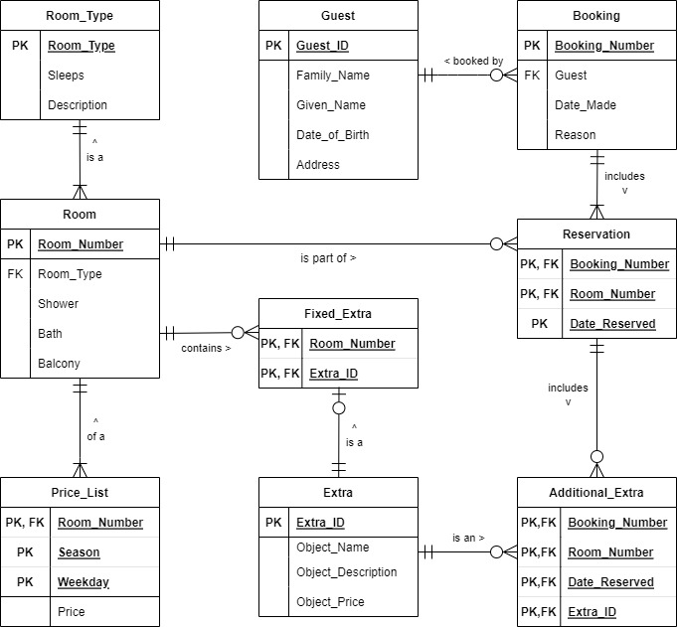

Figure 1

Assignment Tasks

For Assignment 1, you need to do the following:

1. **Download CW_Assessment.sql from CANVAS**
2. Follow the instructions **CAREFULLY** inside this file, it tells you what to do   
   and **how to submit** your work.
3. Other than adding your queries in the indicated slots, **do NOT alter the   
   file**.
4. Download **Hatfield_Hotel_Tables_and_Data.sql** from CANVAS.
5. Run this inside SQL Developer.
6. 9 new tables will be created on your account each starting **A2_...**  
   These are the tables to use in your queries, PL/SQL blocks, tigger and exception handling so you will need to reference   
   them with the A2_ at the front anytime you use them.
7. Data may also be inserted into the tables, only add extra data as instructed.

MAX TOTAL MARKS = 100